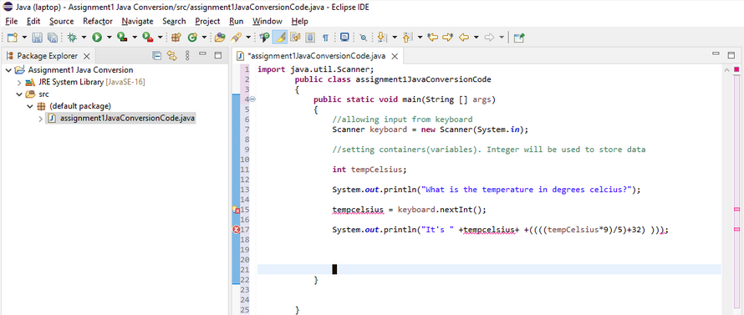

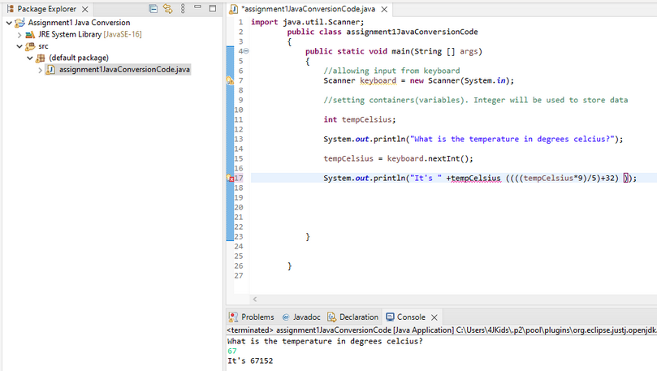

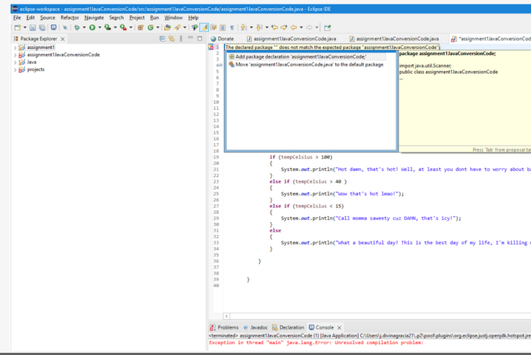

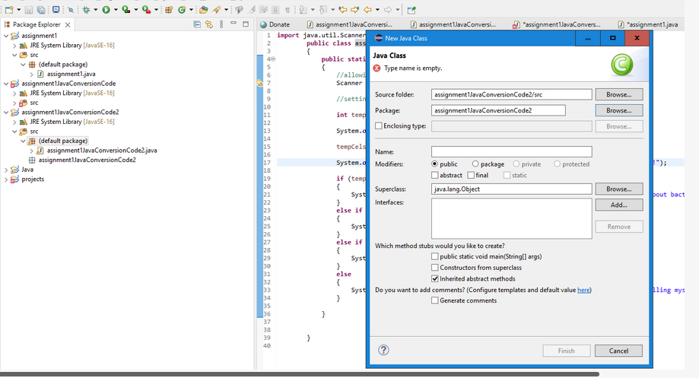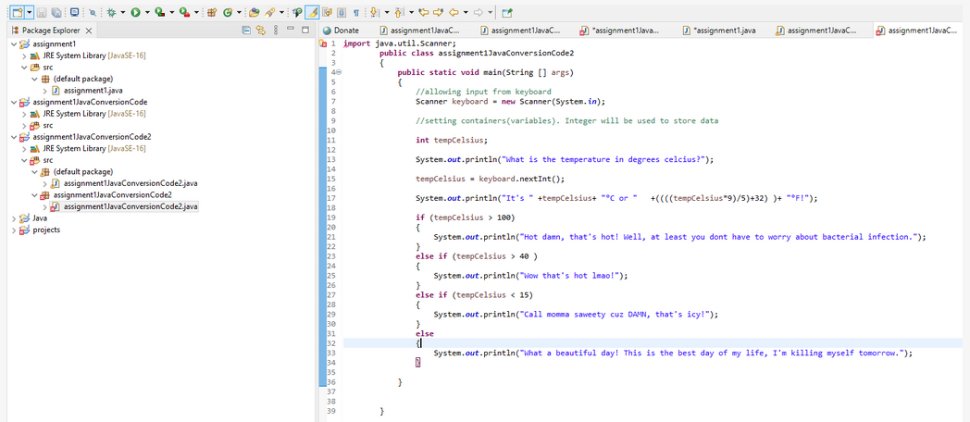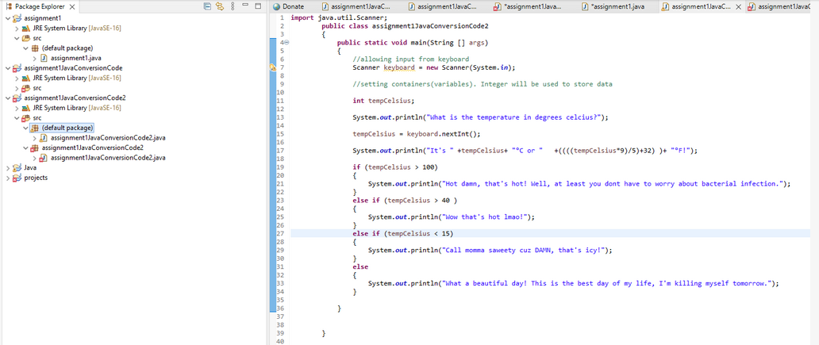eclipse-workspace - assignmentIJavaConversionCode2/src/assignmentIJavaConversionCode2.java - 
Eile Edit Source Refactor Navigate Search project Bun Window 
Help 
Donate 
Eclipse IDE 
u:] assignmentIJavaC.. 
Package Explorer X 
assignmentl 
JRESystem Library [JavaSE-16] 
v (default package) 
u:] assignment I java 
assignment I JavaConversionCode 
JRESystem Library [JavaSE-16] 
assignment I JavaConversionCode2 
JRESystem Library [JavaSE-16] 
(default package) 
assignment I JavaConversionCode2java 
assignmentl JavaConversionCode2 
assignment I JavaConversionCode2java 
projects 
assignmentIJavaC... 
•assignmentIJava.. 
*assignmentl.java 
assignmentIJava... 
X 
assignmentIJa' 
import java. util.Scanner; 
public class assignmentIJavaConversionCode2 
public static void main (String args) 
/ 'allowing input from keyboard 
Scanner = new Scanner(System. in); 
/ 'setting containers (variables). Integer will be used to store data 
int tempCeIsius; 
is 
the temperature in degrees celcius?"); 
tempCeIsius = keyboard. nextlnt(); 
if (tempCeIsius > 
tempCeIsius+ 
too hot! Well, 
else if (tempCeIsius > 4ø ) 
that's hot!"); 
else if (tempCeIsius < 15) 
or 
at least you dont have to worry about bacterial infection. 
Elsa and Anna cause that's icy!"); 
else 
a beautiful day! This is the best day of my life! (so far). 
Problems @ Javadoc Declaration Console 
assi nmentIJavaConversionCode2 [Java A 
What is the temperature in degrees celcius? 
It's løøoc or 2120F! 
Wow that's hot! 
x 
lication] •.divi 
racia21 
Iu ins\or .ecli 
endk.hots 
:re.full.win32x86 64 170.0...,20211012 

File 
clipse-workspace - assignmentIJavaConversionCode2/src/assignmentIJavaConversionCode2.java - 
Edit Source Refactor Navigate Search project Bun Window 
Help 
Donate 
Eclipse IDE 
u:] assignmentIJavaC... 
Package Explorer X 
assignmentl 
JRESystem Library [JavaSE-16] 
v (default package) 
u:] assignment I java 
assignment I JavaConversionCode 
JRESystem Library [JavaSE-16] 
assignment I JavaConversionCode2 
JRESystem Library [JavaSE-16] 
(default package) 
assignment I JavaConversionCode2java 
assignmentl JavaConversionCode2 
assignment I JavaConversionCode2java 
projects 
assignmentIJavaC... 
•assignmentIJava.. 
*assignmentl.java 
assignmentIJava... 
X 
assign 
import java. util.Scanner; 
ublic class assignmentIJavaConversionCode2 
public static void main (String args) 
/ 'allowing input from keyboard 
Scanner keyboard = new Scanner(System. in); 
/ 'setting containers (variables). Integer will be used to store data 
int tempCeIsius; 
is 
the temperature in degrees celcius?"); 
tempCeIsius = keyboard. nextlnt(); 
tempCeIsius+ "oc or " 
if 
too hot! 
well, 
else if ) 
that's hot!")• 
else if 
at least you dont have to payry about bacterial infection. 
Elsa and Anna cause that's icy!"); 
else 
a beautiful day! This is the best day of my life! (so far). 
Problems @ Javadoc Declaration Console 
assi nmentIJavaConversionCode2 [Java A 
What is the temperature in degrees celcius? 
It's løøoc or 2120F! 
Wow that's hot! 
x 
lication] •.divi 
racia21 
Iu ins\or .ecli 
endk.hots 
:re.full.win32x86 64 170.0...,: 

eclipse-workspace - assignmentIJavaConversionCode2/src/assignmentIJavaConversionCode2.java - 
Eile Edit Source Refactor Navigate Search project Bun Window 
Help 
Donate 
Eclipse IDE 
u) assignmentIJavaC... 
Package Explorer X 
assignmentl 
JRESystem Library [JavaSE-16] 
v (default package) 
u:] assignment I java 
assignment I JavaConversionCode 
JRESystem Library [JavaSE-16] 
assignment I JavaConversionCode2 
JRESystem Library [JavaSE-16] 
(default package) 
assignment I JavaConversionCode2java 
assignmentl JavaConversionCode2 
assignment I JavaConversionCode2java 
projects 
u) assignmentIJavaC... 
•assignmentIJava.. 
0) •assignmentl.java 
import java. util.Scanner; 
public class assignmentIJavaConversionCode2 
public static void main (String args) 
/ 'allowing input from keyboard 
Scanner = new Scanner(System. in); 
/ 'setting containers (variables). Integer will be used to store data 
int tempCeIsius; 
is 
the temperature in degrees celcius?"); 
tempCeIsius = keyboard. nextlnt(); 
tempCeIsius+ "oc or " 
if (tempCeIsius 
too hot! Well, 
else if (tempCeIsius 
that's hot!"); 
else if (tempCeIsius 15) 
else 
Problems @ Javadoc Declaration Console 
assi nmentIJavaConversionCode2 [Java A 
What is the temperature in degrees celcius? 
tvs løøoc or 2120F! 
That's tco hot! Well, at least you dont have 
at least you dont have to payry aboud 
Elsa and Anna cause that's icy!"); 
a beautiful day! This is the best day of my life! (so f 
x 
lication] 
Idivina racia21\. 
Iu ins\or .ecli 
e:ustlo endk.h 
to worry about bacterial infection. 

Machine generated alternative text:
Package Explorer X 
assignmentl 
assignment I JavaConversionCode 
assignment I JavaConversionCode2 
projects 
Donate 
import 
O] assignmentIJavaC... 
java . util. Scanner; 
assignmentIJavaC... 
assignmentIJavaC... 
assignmentl.java 
assignmentIJava... 
X 
assignmentIJava• 
public class assignmentIJavaConversionCode2 
public static void main (String args) 
/ 'allowing input from keyboard 
Scanner = new Scanner(System. in); 
/ 'setting containers (variables). Integer will be used to store data 
int tempCeIsius; 
is 
the temperature in degrees celcius?"); 
tempCeIsius = keyboard. nextlnt(); 
tempCeIsius+ "oc or " 
if (tempCeIsius 
too hot! 
well, 
else if (tempCeIsius 
that's hot!")• 
else if (tempCeIsius 15) 
else 
public static void info d] 
at least you dont have to payry about bacterial infection. " 
Elsa and Anna cause that's icy!"); 
a beautiful day! This is the 
String name = showInputDiaIog(nuII, "Hi! What 
String age Type = showInputDiaIog(nuII, "Okay 
Agg. = a String value 
best day of my life! (so far)."); 
is your name? 
"*name 
what age are you?"); 
to an integer 

Machine generated alternative text:
Package Explorer X 
assignmentl 
assignment I JavaConversionCode 
assignmentIJavaConversionCode2 
projects 
Donate 
I import 
O] assignmentIJavaC... 
java . util. Scanner; 
assignmentIJavaC... 
assignmentIJavaC... 
assignmentl.java 
Æ_] assignmentIJavaC... 
X 
assignmentIJavaC... 
public class assignmentIJavaConversionCode2 
public 
public 
static void main (String args) 
/ 'allowing input from keyboard 
r = new Scanner(System. in); 
Scanne 
/ 'setting containers (variables). Integer will be used to store data 
int tempCeIsius; 
is 
the temperature in degrees celcius?"); 
tempCeIsius = keyboard. nextlnt(); 
tempCeIsius+ "oc or " 
if (tempCeIsius 
too hot! 
well, 
else if (tempCeIsius 
that's hot!")• 
else if (tempCeIsius 15) 
else 
static void info() 
at least you dont have to payry about bacterial infection. " 
Elsa and Anna cause that's icy!"); 
a beautiful day! This is the best day of my life! (so far). 
String tempCeIsius = showInputDiaIog(nuII, "What is the temperature in degrees celcius?"); 
tempCeIsiu s 
a String value to an integer 

Machine generated alternative text:
Package Explorer X 
assignment I 
assignment I JavaConversionCode 
assignmentIJavaConversionCode2 
p rojects 
Donate 
import 
Problems 
assignmentIJavaC... 
java . util. Scanner; 
assignmentIJavaC... 
assignmentIJavaC... 
assignm entl .java 
assignmentIJavaC... 
x 
assignmentIJavaC... 
public class assignmentIJavaConversionCode2 
public static void main (String args) 
/ 'allowing input from keyboard 
r = new Scanner (System. in); 
Scanne 
/ 'setting containers (variables). Integer will be used to store data 
int tempCeIsius; 
is 
the temperature in degrees celcius?"); 
tempCeIsius = keyboard. nextlnt(); 
tempCeIsius+ "oc or " 
if (tempCeIsius 
too hot! 
well, 
else if (tempCeIsius 
that's hot!")• 
else if (tempCeIsius 15) 
else 
public static void info() 
at least you dont have to payry about bacterial infection. " 
Elsa and Anna cause that's icy!"); 
a beautiful day! This is the best day of my life! (so far). 
String tempCeIsius = showInputDiaIog(nuII, "What is the temperature in degrees celcius?"); 
tempCeIsius = a String value to an integer 
@ Javadoc Declaration Console 
x 
lication] 
assi nmentIJavaConverslonCode2 [Java A 
What is the temperature in degrees celcius? 
tvs 340C or 930F! 
Idivina racia21\. 
far) • 
Iu ins\or 
.ecll 
e:ustlo endk.hots ot:re.fuII.win32.x86 64 17.0.O.v20211012-10 
What a beautiful day! This is the best day of my life! (so 

Machine generated alternative text:
import javax. swing. * • 
public class assignmentIJavaConversionCode2 
public static void main (String args) 
/ 'allowing input from keyboard 
keyboard = new in); 
/ 'setting containers (variables). Integer will be used to store data 
int tempCeIsius; 
is 
the temperature in degrees celcius?"); 
tempCeIsius = keyboard. nextlnt(); 
tempCeIsius+ "oc or " 
if (tempCeIsius 
too hot! 
well, 
else if (tempCeIsius 
that's hot!")• 
else if (tempCeIsius 15) 
else 
public static void info() 
String tempCeIsiusType 
at least you dont have to payry about bacterial infection. " 
Elsa and Anna cause that's icy!"); 
a beautiful day! This is the best day of my life! (so far). 
JOptionPane.showInputDiaLog(nuII, "What is the temperature in degrees celcius?"); 
= a String value to an integer 

Machine generated alternative text:
import javax. swing. * • 
public class assignmentIJavaConversionCode2 
public static void main (String args) 
/ 'setting containers (variables). 
int tempCeIsius; 
Integer will be used to store data 
is the temperature in degrees celcius?"); 
ey>gbcd. nextl ( ) ; 
tempCeIsiu s 
tempCeIsius+ "oc or " 
if (tempCeIsius 
too hot! 
well, 
else if (tempCeIsius 
that's hot!")• 
else if (tempCeIsius 15) 
else 
public static void info() 
String tempCeIsiusType 
at least you dont have to payry about bacterial infection. 
Elsa and Anna cause that's icy!"); 
a beautiful day! This is the best day of my life! (so far). 
JOptionPane.showInputDiaLog(nuII, "What is the temperature in degrees celcius?"); 
= a String value to an integer 

Machine generated alternative text:
import javax. swing. * • 
public class assignmentIJavaConversionCode2 
public static void main (String args) 
/ 'setting containers (variables). 
int tempCeIsius; 
is 
tempCeIsius = nextlnt(); 
if (tempCeIsius 
Integer will be used to store data 
the temperature in degrees celcius?"); 
tempCeIsius+ "oc or " 
JOptionPane.shoWdessageDiaLog(nuII, "That's too hot! Well, 
else if (tempCeIsius 4ø ) 
JOptionPane.shoWdessageDiaLog(nuII, "Wow that's hot!"); 
else if (tempCeIsius 15) 
else 
public static void info() 
at least you dont have to payry about bacterial infection. " 
JOptionPane.shoWdessageDiaLog(nuII, "Call Elsa and Anna cause that's icy!"); 
a beautiful day! This is the best day of my life! (so far)." • 
String tempCeIsiusType = JOptionPane.showInputDiaLog(nuII, "What is the temperature in degrees celcius?"); 
= a String value to an integer 

Machine generated alternative text:
import javax. swing. * • 
public class assignmentIJavaConversionCode2 
Integer will be used to store data 
"oc or " 
3 38 
public 
public 
static void main (String args) 
/ 'setting containers (variables). 
int tempCeIsius; 
if 
JOptionPane.shoWdessageDiaLog(nuII, "That's too hot! Well, 
else if 4ø ) 
JOptionPane.shoWdessageDiaLog(nuII, "Wow that's hot!"); 
else if 15) 
else 
static void info ( ) 
at least you dont have to payry about bacterial infection. 
JOptionPane.shoWdessageDiaLog(nuII, "Call Elsa and Anna cause that's icy!"); 
JOptionPane.shoWdessageDiaLog(nuII, "What a beautiful day! This is the best day of my life! (so far). 
String tempCeIsiusType = JOptionPane.showInputDiaLog(nuII, 
"What is the temperature in degrees celcius?"); 
= a String value to an integer 

128 
import javax. swing. * • 
public class assignmentIJavaConversionCode2 
static int tempCeLsius=ø ; 
public static void main (String args) 
info() ; 
out ( ) ; 
public static void out() 
/ 'setting containers (variables). 
int tempCeIsius; 
if 
Integer will be used to store data 
"oc or " 
JOptionPane.shoWdessageDiaLog(nuII, "That's too hot! Well, at least you dont have to payry about bacterial infection. 
else if 4ø ) 
JOptionPane.shoWdessageDiaLog(nuII, "Wow that's hot!"); 
else if 15) 
JOptionPane.shoWdessageDiaLog(nuII, "Call Elsa and Anna cause that's icy!"); 
else 
JOptionPane.shoWdessageDiaLog(nuII, "What a beautiful day! This is the best day of my life! (so far). 
public static void info() 
String tempCeIsiusType = JOptionPane.showInputDiaLog(nuII, 
"What is the temperature in degrees celcius?"); 
tempCeL s us 
a String value to an integer 

File Edit Source 
Package Explorer 
assignmentl 
Refactor 
x 
Navigate Search 
project 
Run Window 
Help 
O] assignmentIJavaC... 
Donate 
import javax. swing. * • 
assignmentIJavaC... 
assignmentIJavaC... 
assignmentl.java 
u:] assignmentIJavaC.. 
assignmentIJavaC... 
assignmentIJavaConversionCode 
assignment I JavaConversionCode2 
v Jav 
JRESystem Library [JavaSE-16] 
projects 
128 
public class assignmentIJavaConversionCode2 
static int tempCeLsius=ø ; 
public static void main (String args) 
info() ; 
out ( ) ; 
public static void out() 
/ 'setting containers (variables). 
Integer will be used to store data 
if (tempCeLsius 
'Option Pa ne. s 
else if (tempCeLsi 
'Option Pa ne. s 
else if (tempCeLsi 
'Option Pa ne. s 
else 
Input 
+tempCeLsius+ "oc or 
What is the temperature in degrees celcius? 
ast you dont have to payry about bacterial infection. " 
at's icy!"); 
JOptionPane.shoWdessageDiaLog(nuII, "What a beautiful day! This is the best day of my life! (so far). 
public static void info() 
String tempCeIsiusType 
etsius = 
Inte er. 
'Option Pa ne. showInputDiaLog ( null, 
"What is 
rselnt tem elsiusT 
; // converts a Strin 
the temperature in degrees celcius?"); 
value to an inte er 

File Edit Source 
Package Explorer 
assignmentl 
Refactor 
x 
Navigate Search 
project 
Run 
Window 
Help 
O] assignmentIJavaC... 
Donate 
import javax. swing. * • 
assignmentIJavaC.. 
assignmentIJavaC... 
assignmentl.java 
u:] assignmentIJavaC... 
>< 
assignmentIJavaC... 
assignment I JavaConversionCode 
assignment I JavaConversionCode2 
v Jav 
JRESystem Library [JavaSE-16] 
projects 
128 
public class assignmentIJavaConversionCode2 
static int tempCeLsius=ø ; 
public static void main (String args) 
info() ; 
out ( ) ; 
public static void out() 
/ 'setting containers (variables). 
Integer will be used to store data 
if (tempCeLsius 
'Option Pane. showtdessa 
else if (tempCeLsius > 
'Option Pa ne. showtde 
else if (tempCeLsius < 
'Option Pa ne. showtde 
else 
+tempCeLsius+ "oc or 
null "That's too hat! Well 
Message 
i Wow that's hot! 
at least you dont have to payry about bacterial infect 
e that's icy!"); 
JOptionPane.shoW4essageDiaLog(nuII, "What a beautiful day! This is the best day of my life! (so far). 
public static void info() 
String tempCeIsiusType 
etsius = 
Inte er. 
Problems @ Javadoc Declaration Console X 
'Option Pa ne. showInputDiaLog ( null, 
"What is the temperature in degrees celcius?"); 
rselnt tem elsiusT 
; // converts a Strin value to an inte er 
assignmentIJavaConversionCode2 [Java Application] 64 

JOptionPane. showt4essageDiaLog(nuII, " It ' s 
if (tempCeLsius 
+tempCeLsius+ "oc or 
'Option Pa ne. s 
else if (tempCeLsi 
'Option Pane. s 
else if (tempCeLsi 
'Option Pa ne. s 
else 
Input 
What is the temperature in degrees celcius? 
ast you dont have to payry about bacterial infr 
at's icy!"); 
JOotionPar 
. shoW4es 
QeDiaLoa(nuII, "Whad 
a be 'tiful day! This is the be: 
dav 
of 
life! (so far).") 

'Option Pane. showt4essageDiaLog(nuII, " It ' s 
+ tempCeLsius+ "oc 
or 
( ( ( ( tempCeLsius* 
if (tempCeLsius 
'Option Pane. showtdessa eDiaL 
Message 
else if (tempCeLsius > 
'Option Pa ne. showtde 
else if (tempCeLsius < 
'Option Pa ne. showtde 
null 
"That's too hot! Well 
at least you dont have 
e that's icy!"); 
to payry about bacter: 
It's or 

'Option Pane. showt4essageDiaLog(nuII, " It ' s 
+ tempCeLsius+ "oc 
if (tempCeLsius 
'Option Pane. showtdessa eDiaL 
null 
"That's too hot! Well 
else if (tempCeLsius > 
'Option Pa ne . showe 
else if (tempCeLsius < 
'Option Pa ne. showtde 
else 
Message 
i Wow that's hot! 
or 
at least you dont have to payry about bacterial infection. 
e that's icy!"); 
JOptionPane.shoW4essageDiaLog(nuII, "What a beautiful day! This is the best day of my life! (so far). 